Introduction
The objective of this report is to present a comprehensive analysis of machine learning applications designed to optimize retail operations, inventory planning, and marketing strategies for the "Play Ringo" brand. The project calculates purchase probabilities to manage intermittent demand, and the goal is to transition from reactive, average-based heuristics to proactive, data-driven decision-making .

Data Description
Dataset used in this project originate from Shopify’s built-in Orders CSV Export feature.
The datasets represent real transactional histories from Play Ringo’s Shopify brand containing more than 10,000 transaction record with an 80-column schema.
This includes structured fields that Shopify automatically records, such as
customer identifiers, billing region, marketing preferences, product quantities and price, discounts, refunds, and overall order financials.

Purchase Probability Model

Problem Statement
- Original Scope:
The initial objective of this project was Stratified Demand Forecasting. The goal was to solve inventory mismanagement—specifically stockouts and overstocking—by predicting the exact Weekly Quantity Sold. The intended approach was to use transparent regression models with engineered features (seasonality, trends) to provide interpretable forecasts for restocking.
- The Challenge (Data Sparsity):
Upon initial analysis, the dataset exhibited extreme data sparsity. A significant portion of the product catalogue consisted of "niche" or "intermittent" demand items, resulting in a time series dominated by zeros.
The application of regression model chosen which included Linear Regression Model, Random Forest Regressor and XGBoost, yielded poor results. Metrics showed negative R² values (indicating the models performed worse than a simple horizontal mean line) and high Mean Absolute Errors (MAE). The data lacked the continuous variance required for accurate quantity forecasting.
- Refined Problem Statement:
To derive actionable business value from sparse data, the problem was reframed from a regression problem ("How many will sell?") to a classification problem ("Will any sell?"). The new objective is to predict the probability of a sale occurring in the next period. This pivot allows the business to transform from passive warehouse management to active growth drivers.

Motivation & Business Usefulness
- Motivation:
Managing Play Ringo’s inventory presents a significant challenge due to the 'Long Tail' nature of its product demand; a few consistent performers contrasted with hundreds of intermittent sellers. This erratic behaviour creates a critical operational dilemma: utilizing standard average-based forecasting for these niche items inevitably results in inefficient capital allocation through excess inventory or, conversely, eroded service levels due to stockouts, both of which undermine long-term profitability.
- Business Usefulness of the Pivot:
Transitioning to a probability-based classification model transforms Play Ringo’s data strategy from a passive restocking mechanism into an active engine for commercial growth. Instead of merely automating inventory replenishment, the model serves as a strategic tool for marketing allocation, empowering the team to identify 'dormant' products with moderate sales potential and target them with specific promotional nudges to drive conversion.
Simultaneously, it enhances financial efficiency by rigorously isolating items with consistently negligible demand, allowing management to make evidence-based decisions on clearance and discontinuation to liberate working capital.

Data Processing
The modelling strategy was designed to transition from a raw transactional log to a predictive classification framework. The process involved was as follows
- Data Aggregation and Time-Series Construction
The raw dataset consisted of individual transaction records. To facilitate time-series forecasting, the data was first aggregated into a unified temporal structure.
  - Created at (Temporal Variable): The exact UTC timestamp of each transaction.
  - Lineitem Type (Categorical Variable): The specific product identifier (e.g., "Red Ringo", "Scorekeeping Pegs").
  - Lineitem quantity (Numerical Variable): The number of units sold per transaction.
The Created at variable was parsed and resampled to a weekly frequency. The data was then grouped by week and Lineitem Type, summing the Lineitem quantity. This transformation converted the dataset from a transaction list into a panel data structure, where every row represents the total activity for one product in one specific week.
- Feature Engineering:
To capture the underlying dynamics of consumer demand—specifically momentum, trend, and product heterogeneity—a set of predictive features was engineered derived exclusively from the three original columns listed above.
- Auto-Regressive (Lag) Features (Momentum):
  - Variable: Qty_Week_Minus_1 (Lag 1) and Qty_Week_Minus_2 (Lag 2).
  - Derivation: Derived by shifting the weekly aggregated Lineitem quantity backwards by 1 and 2 weeks, respectively.
  - Theoretical Justification: These features capture short-term momentum. In retail, recent sales activity is often the strongest predictor of near-future demand.
- Rolling Window Statistics (Trend):
  - Variable: Rolling_Mean_4.
  - Derivation: A 4-week moving average calculated on the shifted sales data.
  - Theoretical Justification: This serves as a smoothing function to mitigate the noise inherent in sparse data. It captures the general monthly trend, distinguishing between a one-off spike and sustained popularity.
- Current State Indicator:
  - Variable: Qty_Week_0.
  - Derivation: The sales quantity of the current observation week.
  - Theoretical Justification: This provides the model with the most immediate context before predicting the subsequent week.
- Categorical Encoding (Heterogeneity):
  - Variable: Type_Encoded.
  - Derivation: The Lineitem Type string was transformed using Label Encoding into a numerical format.
  - Theoretical Justification: This allows the model to learn and differentiate between product categories.
- Model Specification: Logistic Regression
Given the high sparsity of the target variable (Weekly Sales), the problem was framed as a Binary Classification task rather than a Regression task.
- Algorithm: Logistic Regression.
- Rationale: This model was selected for its interpretability. The Logistic Regression provides Odds Ratios, allowing for a transparent explanation of why a product is flagged as a high probability.
- Target Variable: A binary flag where 1 indicates Quantity > 0 (Sales Occurred) and 0 indicates Quantity = 0 (No Sales) for the next week (t+1).
- Training Protocol
- Health Check: Variance Inflation Factor (VIF) analysis was conducted, with all features scoring < 5, indicating no multicollinearity issues.
- Data Splitting: The dataset was partitioned into a Training Set (80%) for parameter estimation and a Test Set (20%) for unbiased evaluation.
- Feature Scaling: A StandardScaler was applied to normalize all numerical features. This step is critical for Logistic Regression to ensure that features with larger ranges (like Lineitem quantity) do not disproportionately influence the model coefficients.

Results
The analysis used Logistic Regression due to its interpretability and comparable performance.
- Model Performance Metrics (Test Set):
The following table displays the model evaluation metrics, generated during the testing phase in order for model evaluation:
Table 1: Model Evaluation Metrics
Model Evaluation Metrics
Accuracy | Precision | Recall | F1 Score | AUC-ROC | AUC-PR
75% | 79% | 54% | 64% | 0.79 | 0.78

The evaluation metrics characterize the model as a highly precise "conservative predictor," achieving an overall Accuracy of 75%. The standout performance lies in its Precision (79%), indicating that when the model forecasts a sale, it is highly reliable; this ensures that business resources are not wasted on false positives. However, this high reliability necessitates a strategic trade-off in Recall (54%), meaning the model acts cautiously and identifies only about half of the actual sales opportunities to rigorously avoid false alarms. Consequently, the F1 Score (64%) reflects this deliberate imbalance, being weighed down by the conservative Recall. Despite this strictness at the default decision boundary, the strong AUC-ROC (0.79) and AUC-PR (0.78) scores confirm that the model possesses a robust underlying capability to correctly distinguish between selling and non-selling weeks, effectively handling the class imbalance inherent in the sparse transaction data.
- Confusion Matrix:

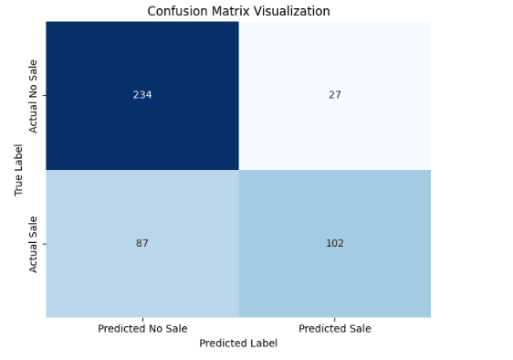
Figure 1: Confusion Matrix

The confusion matrix reveals a model that is fundamentally accurate but cautious. The model correctly identified 234 non-selling weeks (True Negatives) and 102 selling weeks (True Positives), demonstrating a solid baseline ability to classify both outcomes. Notably, the model is highly precise, generating only 27 False Positives, which means it rarely wastes resources by raising false alarms for products that won't sell. However, this conservative approach comes at a cost: it produced 87 False Negatives, representing "missed opportunities" where the model failed to flag a sale that actually occurred. This imbalance suggests the model's default setting prioritizes reliability over aggression, minimizing risk but leaving potential revenue on the table—a finding that directly motivated the subsequent decision to lower the classification threshold (Current decision threshold = 0.5, which is default for Logistic regression).

Insights and Discussion
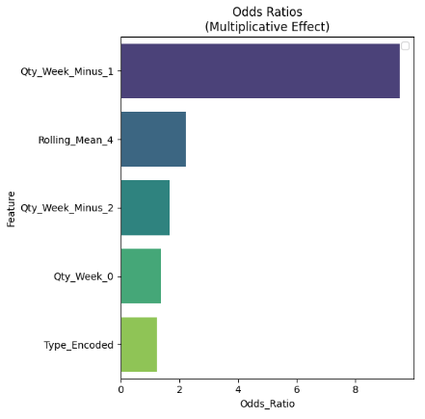
- Feature Importance (Odds Ratio):
Figure 2: The Odds Ratio for Logistic Model
The Odds Ratio has been used in this model to explain feature importance. The Odds Ratio is a metric derived by exponentiating the logistic regression coefficients. It represents the multiplicative change in the odds of the outcome (e.g., a Sale) occurring for every one-unit increase in a feature.
Ratios are the standard for interpreting Logistic Regression because they translate abstract "log-odds" into real-world effect sizes. While raw coefficients indicate direction (positive/negative), Odds Ratios allow us to rank features by the magnitude of their impact. The feature importance analysis using Odds Ratio revealed that Qty_Week_Minus_1 is the dominant predictor with an Odds Ratio of ~9.5. This means that if a product sold last week, it is nearly 10 times more likely to sell this week. The business is heavily driven by immediate momentum rather than long-term seasonality.
- Decision Threshold Strategy:
The model's conservative nature meant that using the standard 0.5 (50%) probability threshold resulted in zero forecasted sales for the next week.
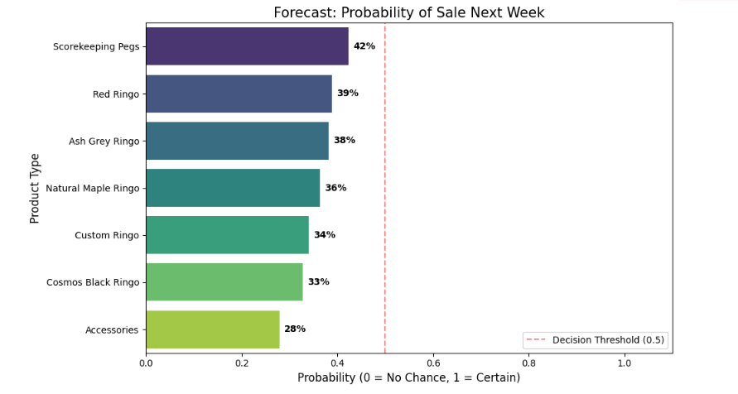
Figure 3: Forecast: Probability of Sales Next Week
- Insight: "Play Ringo" products often hover in the 35-45% probability range.
- Action: By performing a Sensitivity Analysis, we determined that lowering the decision threshold to 0.30 - 0.35 effectively balances risk and reward. This adjustment allowed us to capture key opportunities without flooding the system with false positives, in other words, allowing us to increase the model’s recall and increasing the chances of capturing more of the “missed sales opportunities”.
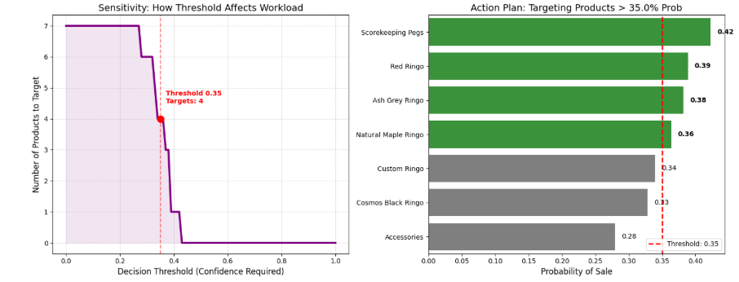
Figure 4: Sensitivity Analysis

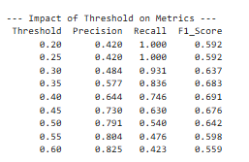
Figure 5: Impact of Threshold on Metrics
- Actionable Forecasts (Next Week):

Using the adjusted threshold, the model identified specific high-potential items:
- Scorekeeping Pegs: 42% Sales Probability
- Ash Grey Ringo: 38% Sales Probability
- Red Ringo: 39% Sales Probability
- Natural Maple Ringo: 36% Sales Probability
By applying the adjusted decision threshold to the forecast for the upcoming week, the model successfully isolated specific, high-potential inventory items that would have otherwise been overlooked. Leading the list of actionable opportunities is Scorekeeping Pegs with a 42% probability of sale; despite recent flat performance, the model detected strong underlying signals of latent potential, making it a prime candidate for activation. Furthermore, the analysis identified building momentum across several core product variants, specifically flagging Red Ringo (39%), Ash Grey Ringo (38%), and Natural Maple Ringo (36%). These probability scores indicate that while these items are not guaranteed sellers, they have crossed the statistical threshold into "active territory," signalling that they are primed for conversion if targeted with the proposed marketing nudges.

